Name: Umamah Binti Aziz
SAP ID: 72012
COAL LAB TASKS
LAB 09
Task 01:
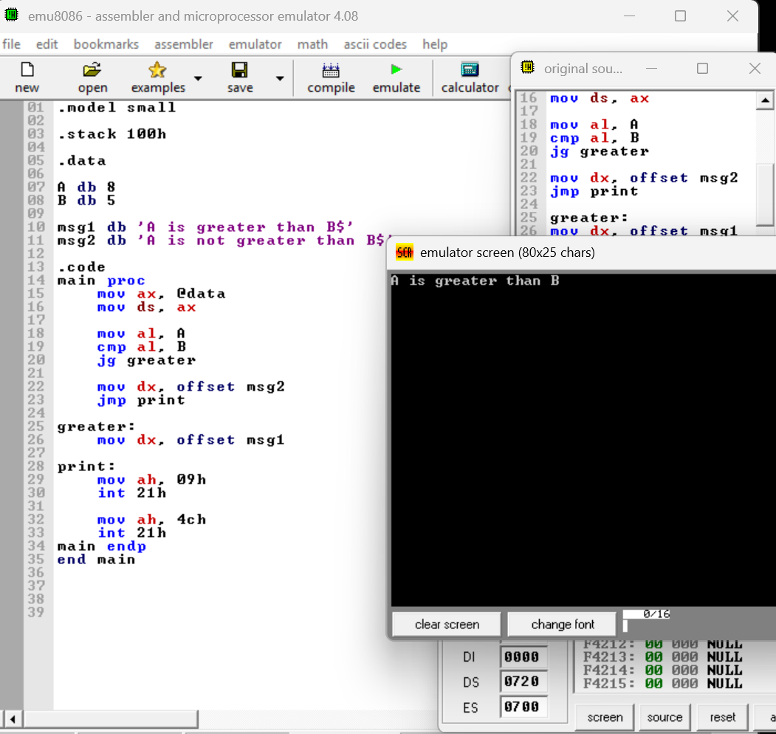

Task 02:
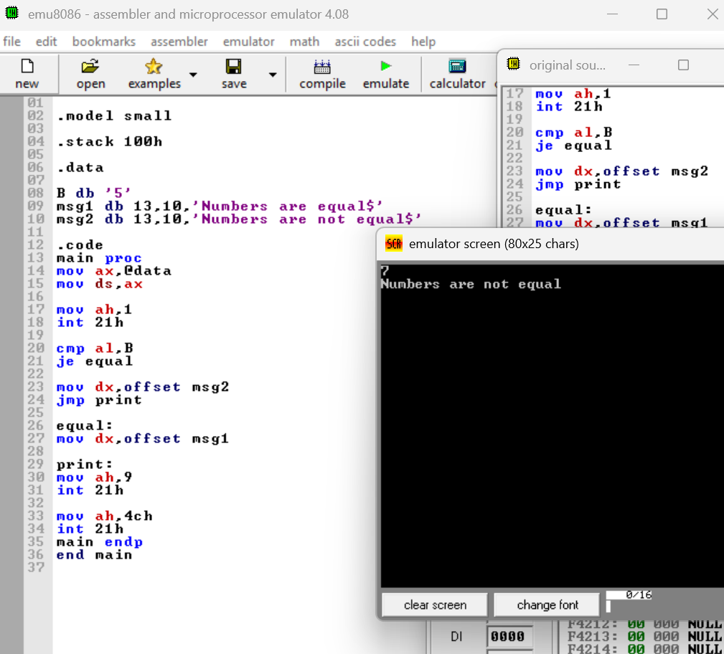

Task 03:
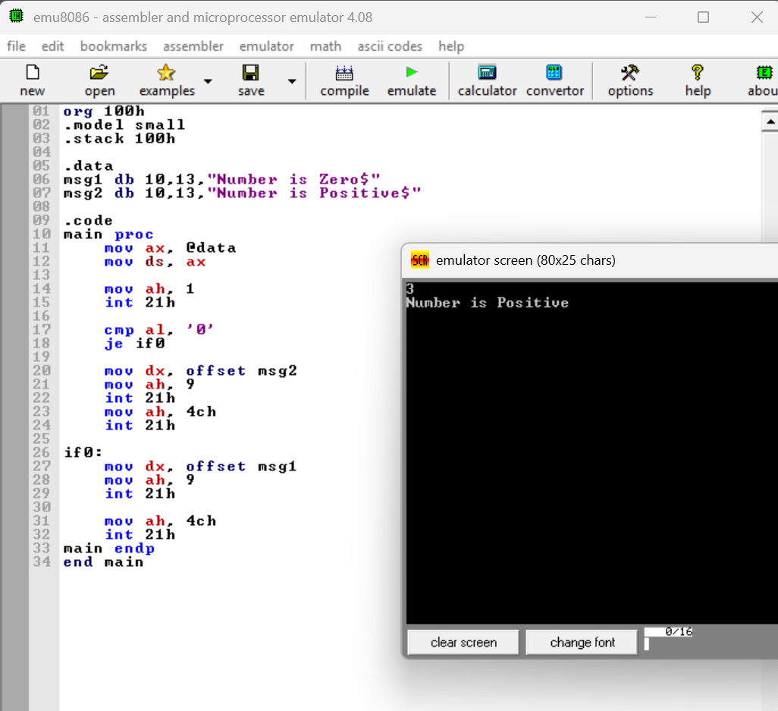

Task 04:
Unconditional Jump:
- An unconditional jump transfers program control to another location without checking any condition.
- It always executes the jump whenever the instruction is reached.
- It uses the JMP instruction.
Example:
mov al,5
jmp skip
mov al,10
skip:
mov bl,20
Conditional Jump:
- A conditional jump transfers program control only when a specific condition is satisfied.
- It executes the jump only if the condition is true.
- It uses instructions such as JE, JNE, JG, JL, and JGE.
Example:
mov al,5
mov bl,5
cmp al,bl
je equal
mov cl,0
jmp finish
equal:
mov cl,1
finish:

